**Project Complete**

**Task 1**

Description:

Creating a simple calculator in C programming using the

If selection statement,

switch Multiple selection statement,

while iteration Statement,

Counter Control iteration,

This program takes an arithmetic operator +, -, *, / and two operands from the user. Then, it performs the calculation on the two operands depending upon the operator entered by the user.

The * operator entered by the user is stored in op. And, the two operands, 1.5 and 4.5 are stored in first and second respectively.

Since the operator * matches case '*':, the control of the program jumps to

printf("%.1lf * %.1lf = %.1lf", first, second, first * second);

This statement calculates the product and displays it on the screen.

To make our output look cleaner, we have simply limited the output to one decimal place using the code %.1lf.

Finally, the break; statement ends the switch statement

**Code:**

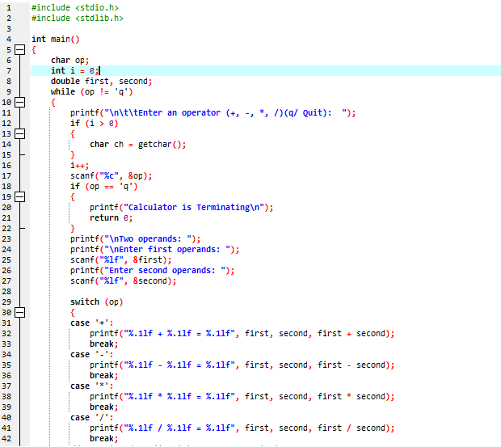

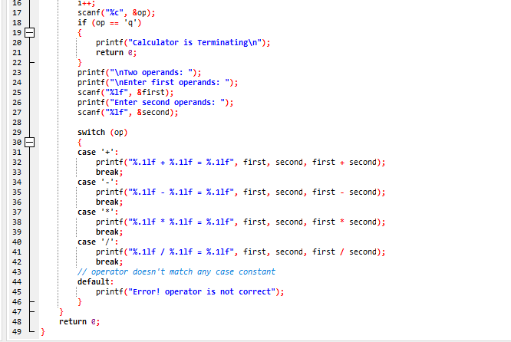

**Output:**

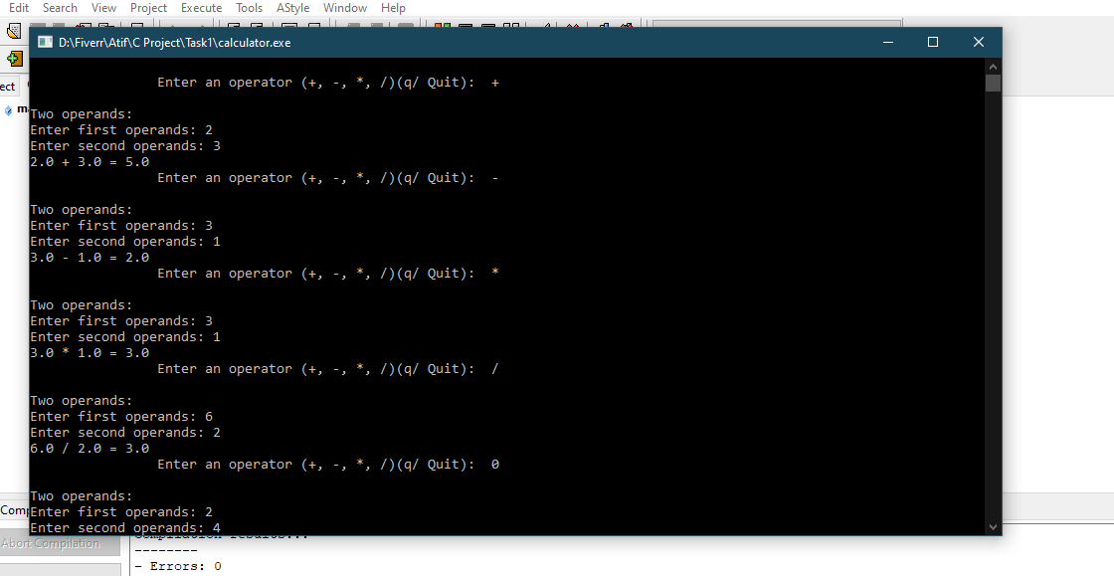

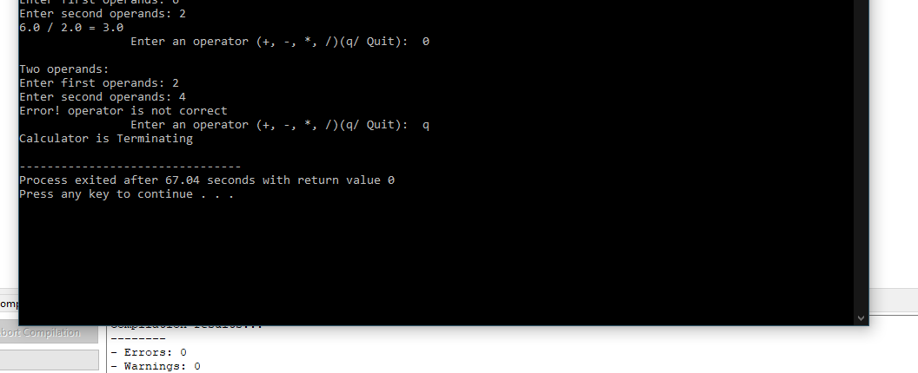

**Task 2**

**Number Converter:**

Description:

The topics we covered in this program is:

Control Structure,

If selection statement,

If else... selection statement,

Nested loop Counter statement

switch Multiple selection statement,

while iteration Statement,

Counter Control iteration,

For iteration statement,

Here is a program for numbers conversion. This program can convert Binary number, decimal number and hexadecimal number to each other respectively.

By entering choice, you can get choice for number conversion.

If user can choice 1, it will convert binary to decimal

For choice 1, it will take binary number and it will output will be in decimal number.

If user can choice 2, it will convert binary to hexa-decimal

For choice 2, it will take binary number and it will output will be in hexa-decimal number.

If user can choice 3, it will convert decimal to binary

For choice 3, it will take decimal number and it will output will be in binary number.

If user can choice 4, it will convert decimal to hexa-decimal

For choice 4, it will take decimal number and it will output will be in hexa-decimal number.

If user can choice 5, it will convert hexa-decimal to binary

For choice 5, it will take hexa-decimal number and it will output will be in binary number.

If user can choice 6, it will convert hexa-decimal to decimal

For choice 6, it will take hexa-decimal number and it will output will be in decimal number.

**Code:**

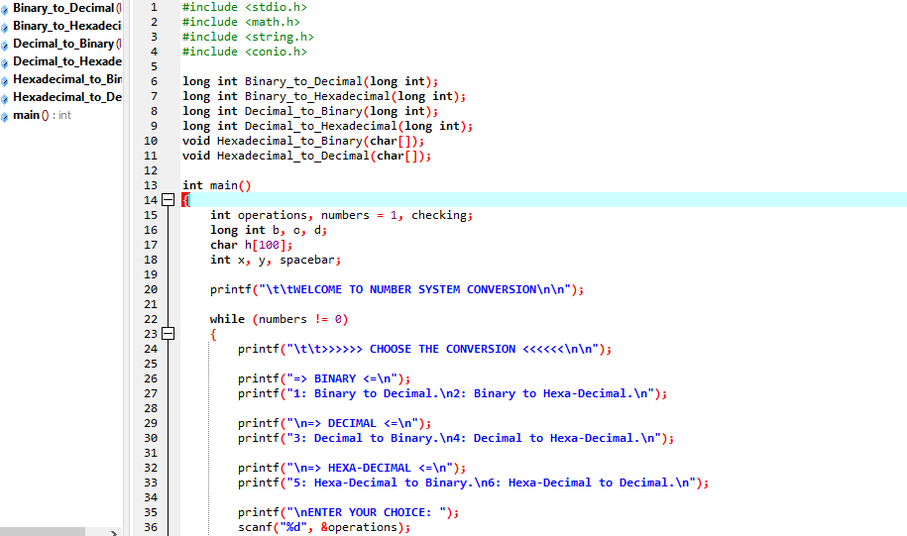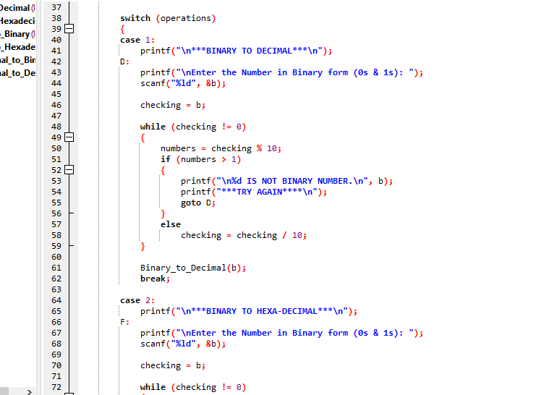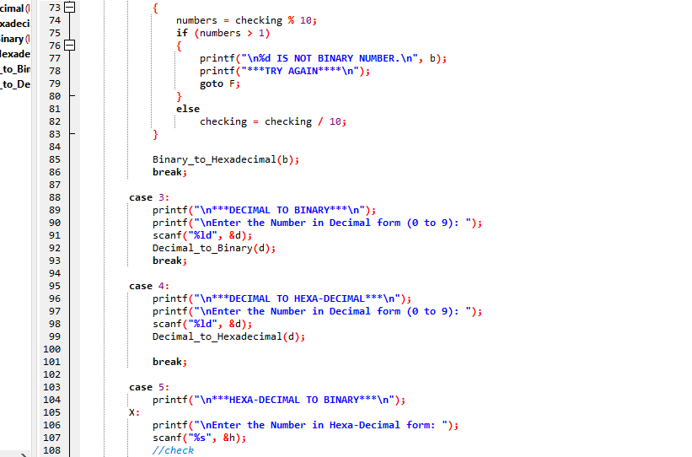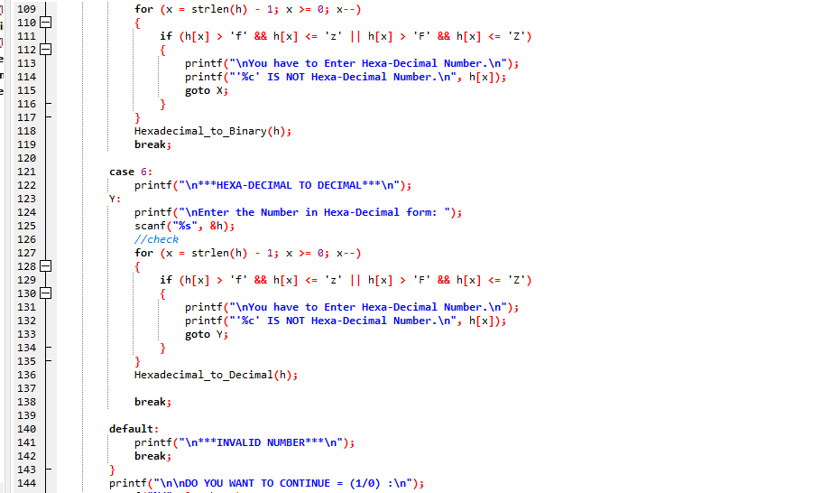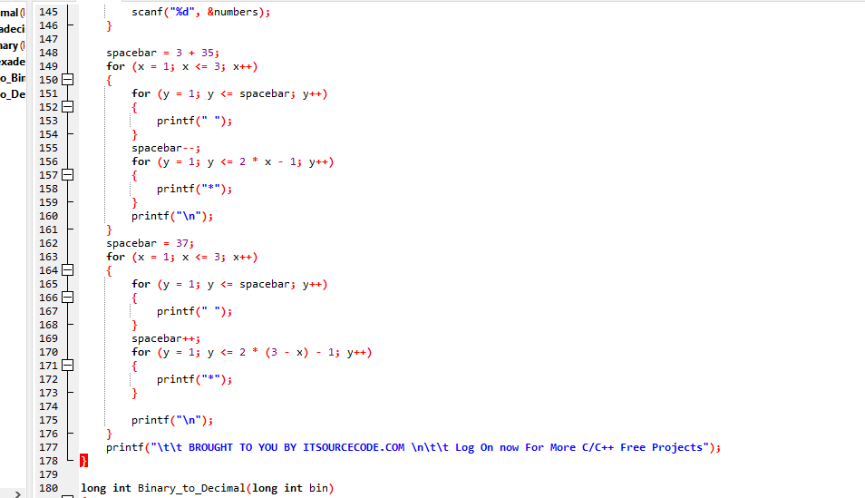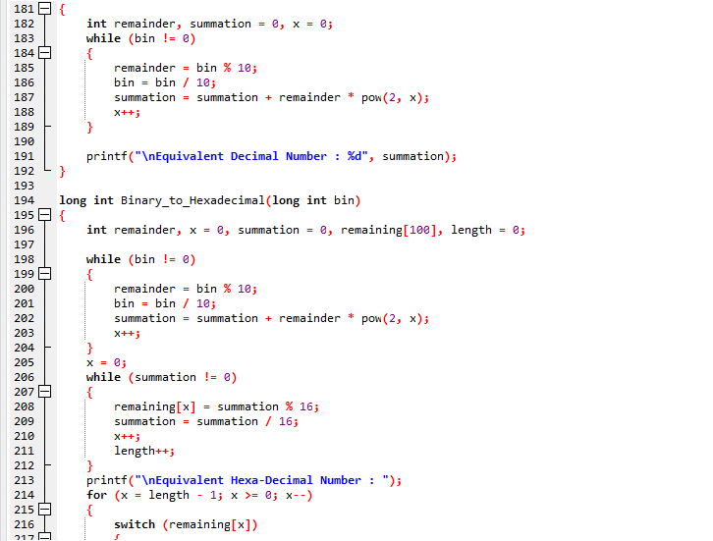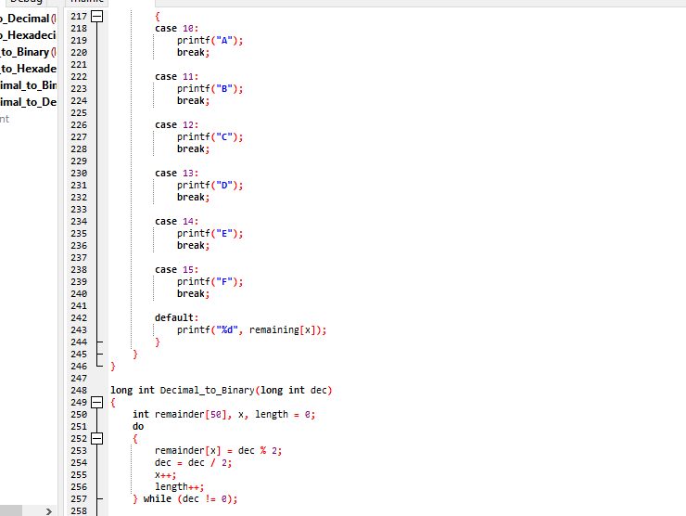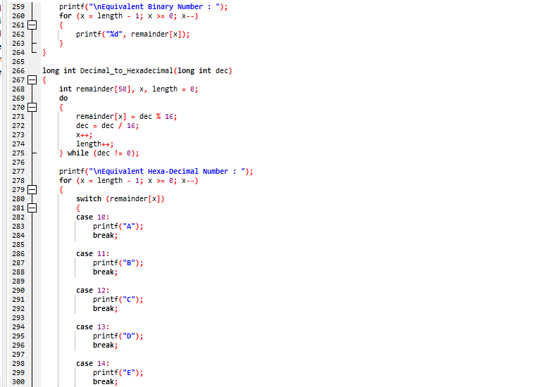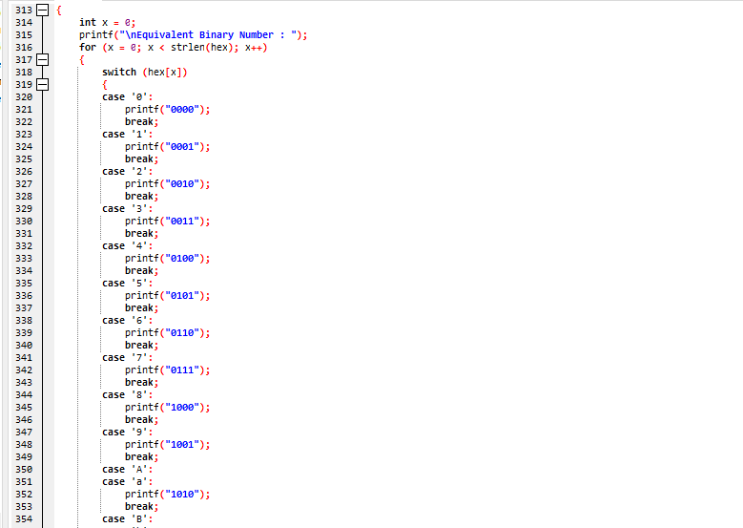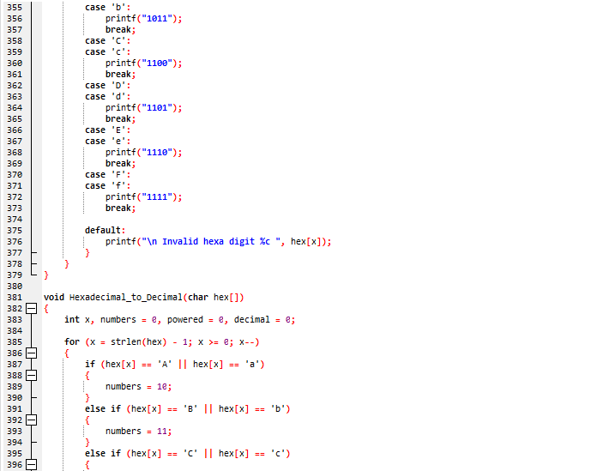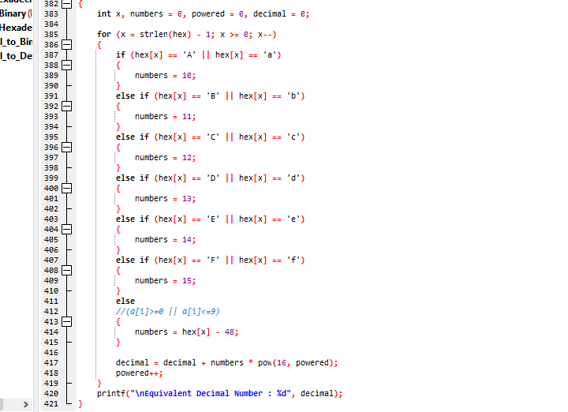

**Output:**

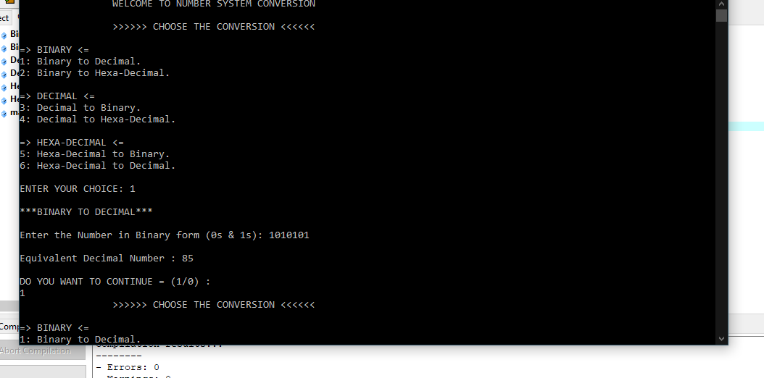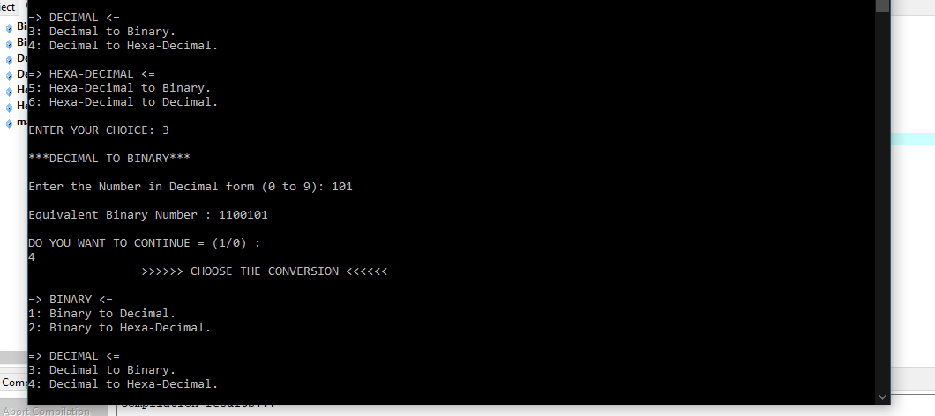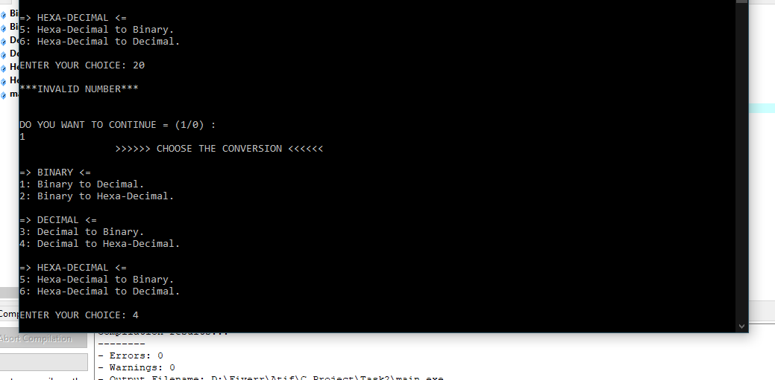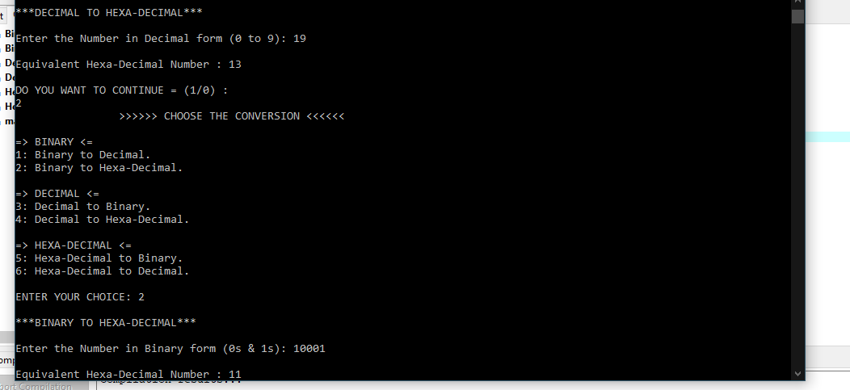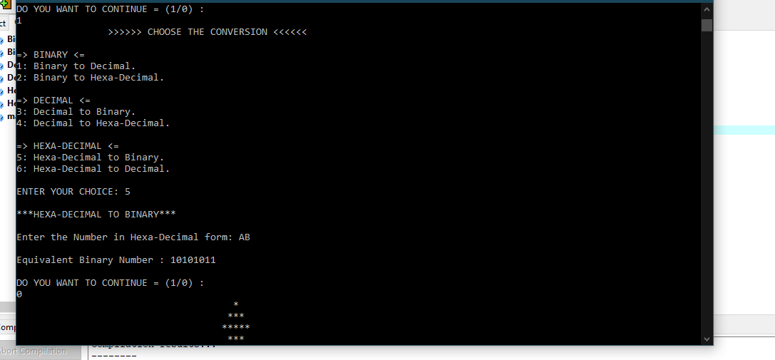

TASK 3

Description:

The topics we covered in this program is:

Control Structure,

If selection statement,

switch Multiple selection statement,

while iteration Statement,

Counter Control iteration,

This program is simple temperature converter.

There is choice option for each conversion, if you want conversion Celsius to Fahrenheit the enter 1 and so on.

Enter 0 to Quit or ending the program

Enter 1. Farhenheit To Celsius

Enter 2. Celsuis To Frahenheit

Enter 3. Celsuis To Kelvin

Enter 4. Kelvin To Celsuis

If user Enter 0, it will quit program.

If user Enter 1, it will ask for Fahrenheit temperature and print temperature in Celsius.

If user Enter 2, it will ask for Celsius temperature and print temperature in farhenheit

If user Enter 3, it will ask for celsius temperature and print temperature in kelvin.

If user Enter 4, it will ask for kelvin temperature and print temperature in Celsius

**Code**:

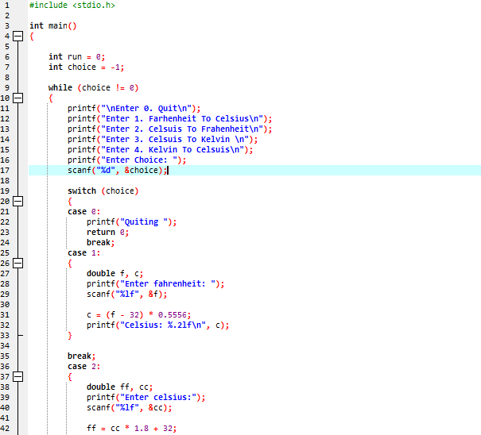

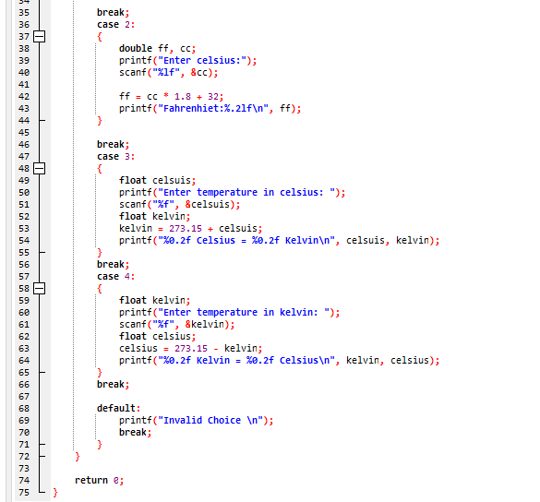

Output:

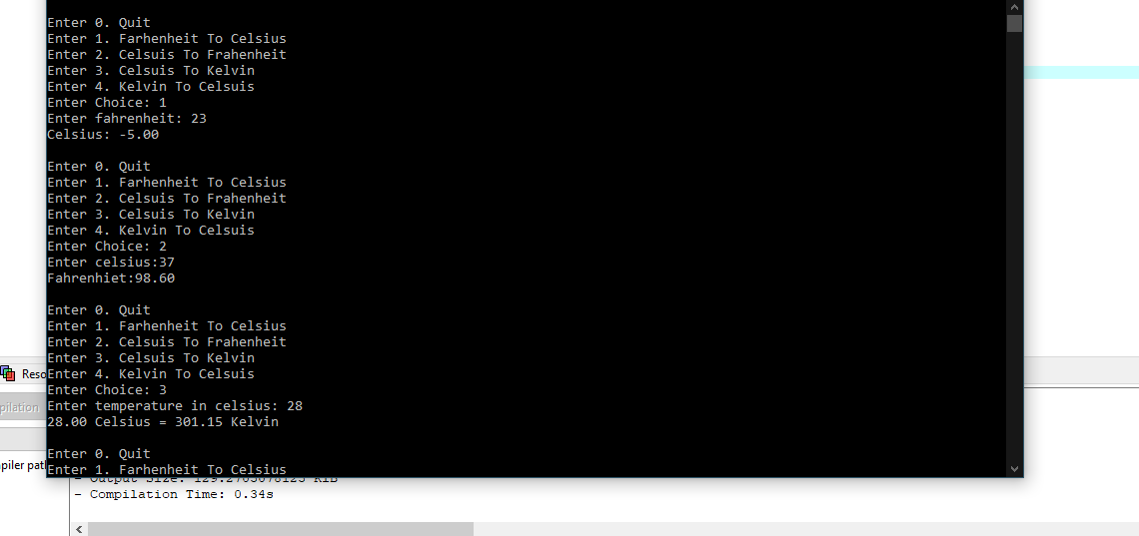

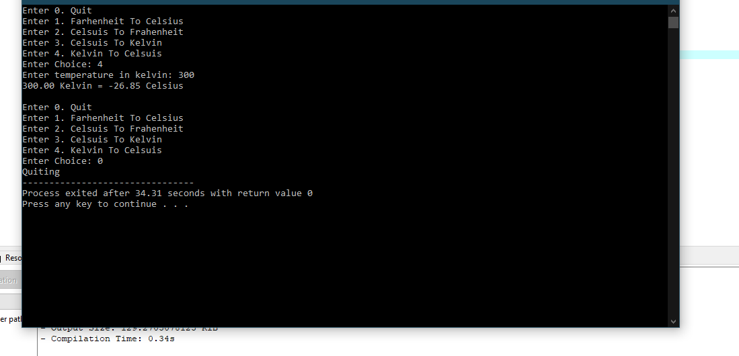

**Task4**

**Areas**

Description:

The topics we covered in this program is:

Control Structure,

If selection statement,

If else... selection statement,

Counter Control iteration,

For iteration statement,

This program takes an arithmetic choice 1, 2, 3, 4 and 5

By choice of 1, it will ask for radius of a circle and find area of that circle.

By choice of 2, it will ask for radius of circle and find out perimeter of circle.

By choice of 3, it will ask for length and width of rectangle and find out area of rectangle.

By choice of 4, it will ask for length and width of rectangle and find out perimeter of rectangle.

At the end it has choice of 5 to quit program.

Code:

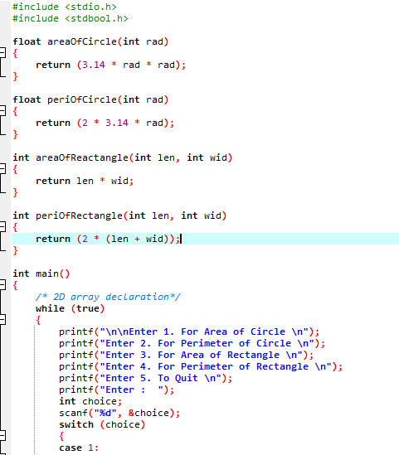

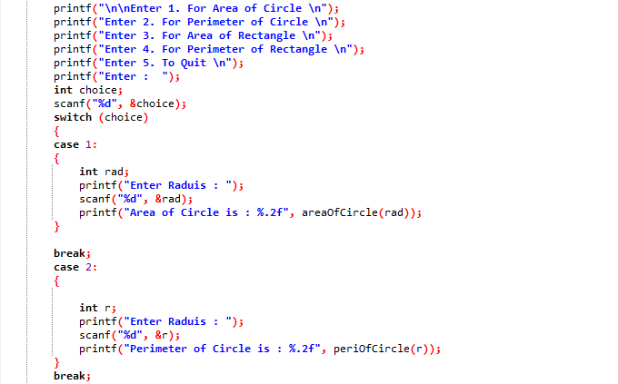

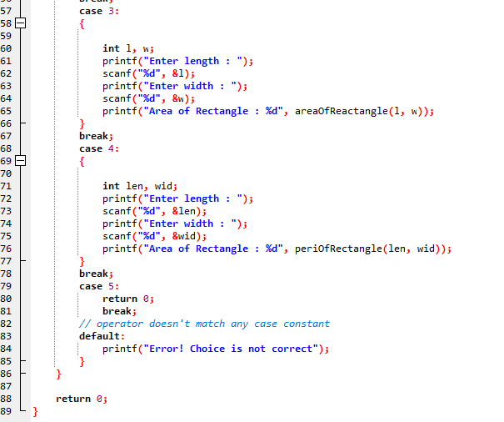

**OUTPUT:**

